**Business problem**

Create a model that tells what are the variables that influenced a person to buy or not a car after being exposed to an add on a social network.

**Explaining the model**

1. Import the dataset, which is in a csv format.
2. We need to get rid of the columns that we won’t look at (gender and ID), so we need to subset the dataset.
3. After that, we will split the dataset into a training and test set (a 75% do the training set will be enough, as our dataset has 400 entries in total).
4. Before creating the classifier, we need to put all values on the same scale (after the sub-setting, the columns have new indexes).
5. After creating the classifier, we create the predictions. The ‘response’ type helps us to place the probabilities on a single vector, and we want to use the test set except the dependent variable (we will later compare the right vs. wrong predictions). The second argument transforms all values on 0 if the probability was <= 0.5, and in 1 if the probability was > 0.5 (it allows us to understand the values more intuitively).

**Plotting the results**

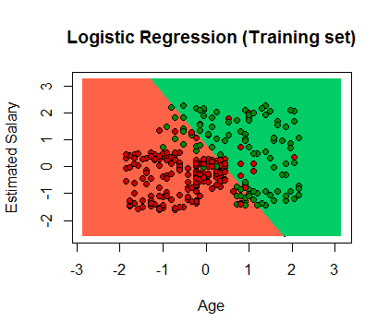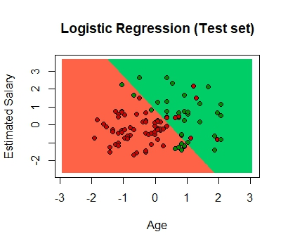

**Evaluating the model’s performance**

The confusing matrix allows us to compare the right vs wrong predictions.

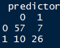

As we can see, we got a total of 83 correct predictions (83%) and 17 wrong predictions (17%), from which 7 are false positives (type I) and 10 are false negatives (type II).